**EDUCATIONAL WEBSITE**

**FOR BEST LEARNING EXPERIANCE**

**TO KNOW THE USER PREFERENCES:**

**Ask from the user to select**

* **Age**
* **Interests**
* **How they spend free time**



**Verification:**

* **Name**
* **Date of birth**
* **Email Id**
* **Address**
* **Mobile number**
* **Educational qualification**

**RECOMMEND MOST POPULAR COURSES TO THE STUDENT**

1. **Python**
2. **Java**
3. **Artificial intelligence**
4. **Web design**
5. **Microsoft excel**
6. **Cyber security**
7. **Data science**

**COMPLETE MULTIPLE COURSES AND EARN CREDITS IN SHORT TERM**

**Access 7000+ courses and specializations from 170+ leading companies and universities.**

**Earn unlimited certificates.**

**Learn job relevant skills and tools with applied projects .**

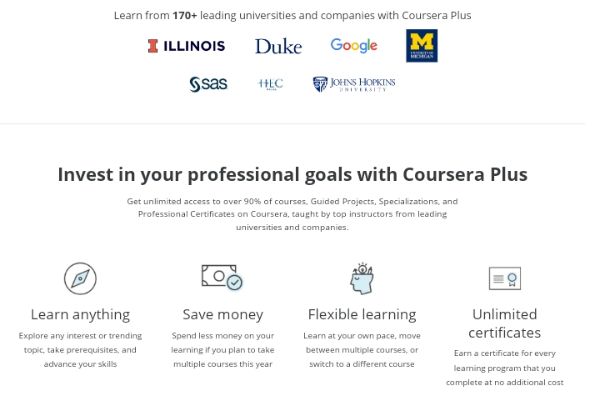

**A learner’s account may show the following details**

* **User info**
* **List of active/completed courses**
* **Info about certificates /points/credits**

**Specializations**

**Every course should have :**

* **Description**
* **Info about its creator**
* **Number of students enrolled**
* **The list of topics and materials**
* **Review section**
* **Completion certificate.**